**ECONOMIC DEVELOPMENT INNOVATION INITIATIVE (EDI2)**

**EVENT OR INDUSTRY PROMOTION**

**Program Performance Report AND REQUEST FOR PAYMENT**

AGENCY: Willingham Associates, LLC

PROGRAM/EVENT: Code for Hillsborough 2015 (formerly Hack for Tampa Bay)

Report Prepared by: Theresa Willingham

I. ACCOMPLISHMENTS: (Consistent with the Performance Evaluation Metrics described in the Agency’s Application Part B(3))

Applying lessons learned from the previous two “Hack for Tampa” events in Hillsborough County, thanks to a strong collaboration with the county Economic Development office, Code for Tampa Bay Brigade, and other great event partners, resulted in the biggest and most successful event yet. Leveraging our robust community networking, and cross promoting across multiple Eureka Factory platforms ensured our biggest turn out to date: 100 participants.

According to plan, and with great thanks to the Economic Development office, we were able to have several community projects available for attendees to choose from for the weekend, which meant everyone was able to engage in programming and development from the start. We were especially happy to be able to engage a youth component that included about a dozen children and mentors from Coder Dojo, who developed a 9-1-1 educational application for children that will be used by Hillsborough County.

Top winning projects from the weekend are:

* Multi-cultural Visitor's Guide team.
* Emergency Preparedness Interactive Map
* Tampa Bay Trade and Protocol Council app.
* Entrepreneur Collaboration Center website enhancement
* Tampa Downtown Partnership Shuttle App

All of these projects and several others will continue to be developed through Code for Tampa Bay Brigade and county agencies and groups where applicable.

By any measure, Code for Hillsborough 2015 was a resounding success, bringing together technologists and area professionals and Hillsborough County government, with the common goal of collaborative citizen engagement. Real and valuable solutions to community needs were identified and presented, and will leave an enduring mark on our community. Of the more than 100 National Day of Civic Hacking events held throughout the nation, Code for Hillsborough was one of the most productive. Another measure of success, as well, is the number of new connections forged, further strengthening our growing tech community. Furthermore, the event was so enjoyable and successful, that a planning team has already been developed for next year’s event.

II. PROBLEMS:

The biggest challenge was obtaining sufficient data from Hillsborough County. Ultimately we fell short there, although not for lack of trying and certainly through no fault of our own, or anyone on the planning team. Thanks to the collaborative efforts of partners and other county agencies and groups, we were able to overcome data challenges by utilizing other data sources to successfully demonstrate proof of concept and develop the frameworks of workable solutions to the challenges presented.

III. OTHER COMMENTS:

This was just a great event all the way around, proving again that events of this scope and caliber are what truly build a sustainability tech and small business community.

A full Post Event report with photos, media and other related information, a Profit & Loss Statement and receipts accompany this narrative report.

We are grateful to Hillsborough County for your support of this tech community building event.

**SUPPORTING ATTACHMENTS:** With each Performance Report, Agency will provide a **Profit and Loss Statement for the Event or Industry Promotion** (containing line items consistent with the projected budget provided in the Agency’s Application for the event).

**ATTESTATION**

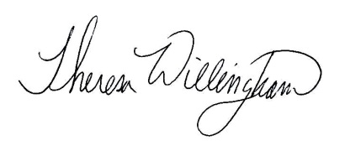I certify that the Project, as described in the EDI2 Award Agreement, has been completed in accordance with the terms and conditions of the Agreement, and that the documentation provided with this request for payment is true, accurate, and complete.

Partner, Willingham Associates, LLC 6/26/2015

Authorized Agency Representative Signature Title Date

Theresa Willingham

Authorized Agency Representative Name Printed

**==============================================================**

**FOR COUNTY USE ONLY**

AMOUNT REQUESTED:_____________________________________

AMOUNT APPROVED BASED ON COUNTY REVIEW:____________________

ACCOUNT CODES: 00005.110706.582990.5520, 00052.110706.582990.5520

I verify that Hillsborough County (based upon certification of Agency Official) has received the goods and/or services.

TYPE OF REVIEW APPROVED DATE

FISCAL _______________

PROGRAMMATIC _______________

_______________

Lindsey Kimball, Managing Director, Economic Development COMMENTS: Payment of the reimbursement request shall be made within fifteen (15) business days after approval of such request by the County.

**Code for Hillsborough 2015 – Post Event Report**

**About Code for Hillsborough 2015**

**Code for Hillsborough at a Glance**

**Event Partners**

**About Eureka Factory**

**Supporting Documents**

Profit & Loss Statement

Receipts

# **About Code for Hillsborough 2015**

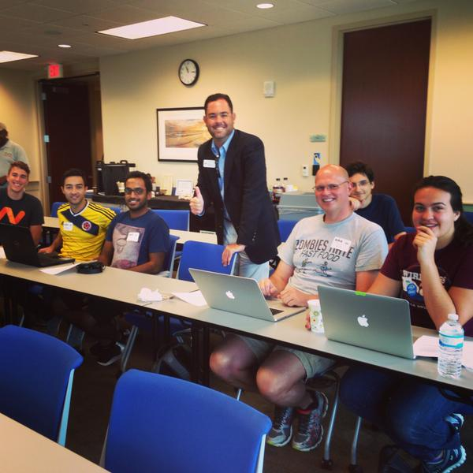The 3rd Annual Code for Hillsborough (formerly Hillsborough Hackathon) event was produced in partnership with Hillsborough County, Florida, Code for Tampa Bay Brigade, Microsoft and other remarkable community partners. In celebration of the National Day of Civic Hacking, we invited urbanologists, civic hackers, government staff, developers, designers, community organizers and anyone with the passion to make their city better, to join us June 5-7, to help build new solutions using publicly-released data, technology, and design processes to improve our communities and government services together.

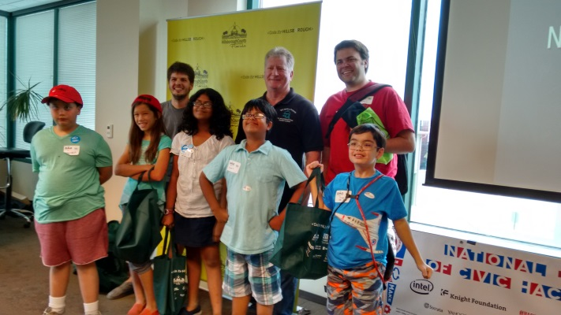Nine challenges were initially identified by Hillsborough County organizations and agencies, and included the first ever statewide Hack for Change challenge, in partnership with the Florida Chief Financial Officer, Jeff Atwater. Participants were not limited to working on these projects, but these were needs identified in our community and which welcomed support in addressing.

* Hillsborough ECC
* Multicultural Visitors Guide
* 9-1-1 Educational App
* Traffic Forecasting App
* Jail Population Management App
* Tampa Bay Trade and Protocol Council App
* Hillsborough Community Atlas
* Downtown Shuttle
* Florida Vendor Payments Challenge

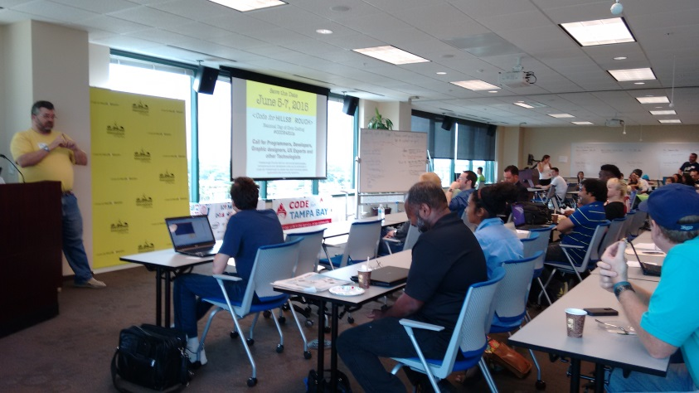One additional project was added by a team at the event, the development of an Emergency Preparedness Interactive Map

The event schedule was as follows:

Friday, June 5

4 p.m. – Code for Tampa Bay Refreshments

4:30 p.m. – Projects Reveal and Weekend Overview

5:30 p.m. – CollabTB After-party

Saturday, June 6

9:30 a.m. – Registration and The Grind Breakfast and Coffee

10 a.m. – Community Projects and Coding begin and continue throughout weekend

Noon – TekBank Lunch

6 p.m. – Forex Factory Dinner

8:30 p.m. – End of Day Wrap-up

9 p.m. – CollabTB After-party

Sunday, June 7

9:30 a.m. – Kahwa Coffee and McDonald’s Breakfast

10 a.m. – Projects and Coding begin

Noon – The Iron Yard Lunch

3 p.m. – Presentations

Attendees enjoyed food throughout the event, courtesy of event partners, and shirts and gifts courtesy of Eureka Factory and other event partners. More importantly, participants contributions have been acknowledged beyond the event, as teams continue to work on the projects they launched at Code for Hillsborough 2015.

# Code for Hillsborough at a Glance

## Attendance – 100 participants – 3x more than 2014

## Corporate Involvement

* More than a dozen local corporate partners

## Media Reach -

* Twitter – In June alone, over 11,000 impressions and 100 new followers on Code for Tampa Bay Brigade
* Listings
  + Code for America National Day of Civic Hacking website
  + Challenge Post
* Popular media – coverage in:
* 83 Degrees Media
* Tampa Tribune
* PR Web
* South Tampa News & Tribune

# 

# Code for Hillsborough Partners

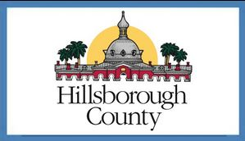





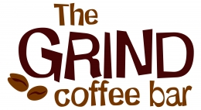

http://hackforchange.org/wp-content/uploads/2015/04/Tekbank-logo-160x44.png

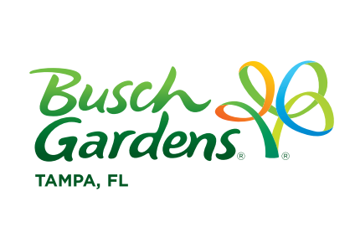



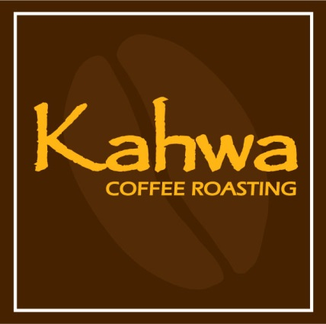

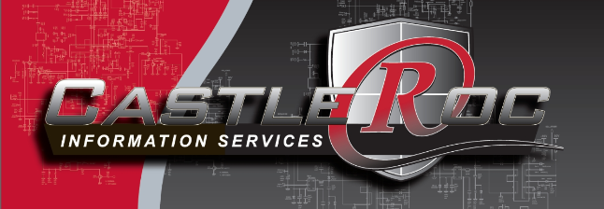http://hackforchange.org/wp-content/uploads/2015/04/logo-laicos-160x36.png

Facebook- Over 2000 reached in one week

******About Eureka! Factory**

The ***Eureka! Factory*** is a collaborative of creative individuals and business partners who believe in the power of community driven innovation to help people move from passive consumption to empowered and active creation of their future and ours. Together, we work as consultants and program developers for libraries and other organizations throughout Tampa Bay. Our work includes:

* Creative Makerspace Development for libraries and other community organizations
* Producing events like *ROBOTICON* Tampa Bay and Gulf Coast MakerCon
* Hosting community and staff development Training and Workshops
* Speaking Engagements & Creative Exhibits

Visit EurekaFactory.net for more information.

# Supporting Documents

*The following documents include required Profit & Loss Statement, plus major receipts for event related expenses not including food or in-kind support, as per EDI2 grant requirements.*

# Profit & Loss Statement

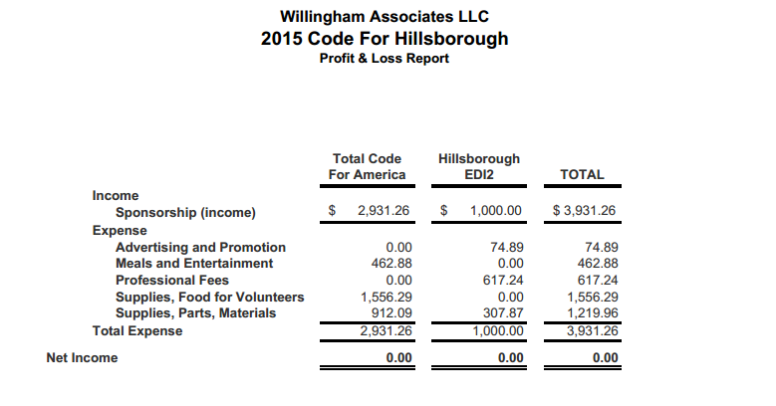

*As perEDI2 guidelines, food costs are not expensed through county funding but were met through Code for America funding support.*

# Code for Hillsborough Receipts

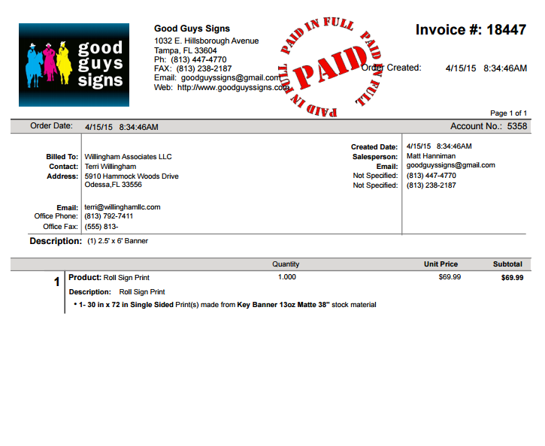***Signage***

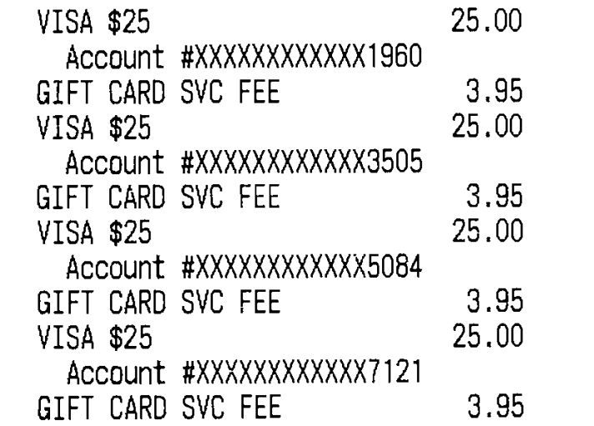 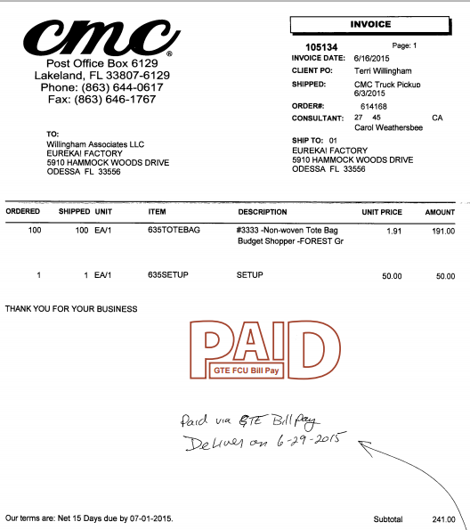

***Gift cards***

***Participant gifts***